Name – Kaung Sat Paing

Student ID – 14399033

Changes -4

Code origin

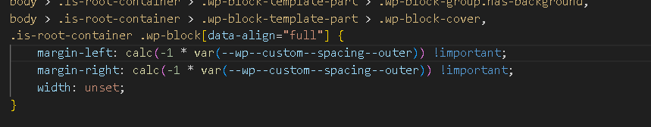

Code Changes

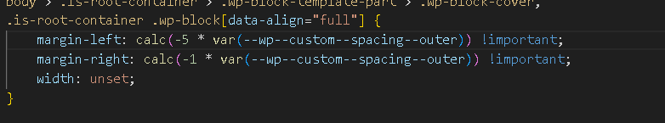

Web Origin

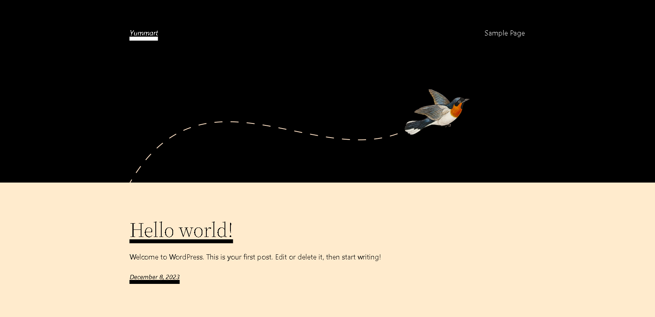

Web Changes

